**EXP-9 Socket Programming - File Transfer**

**K. Priya(4600)**

**Server Program:**

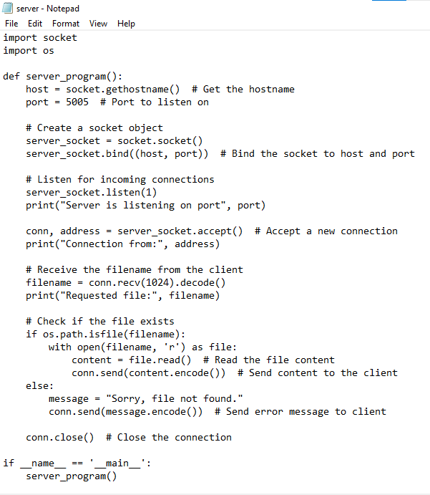

**Client Program:**

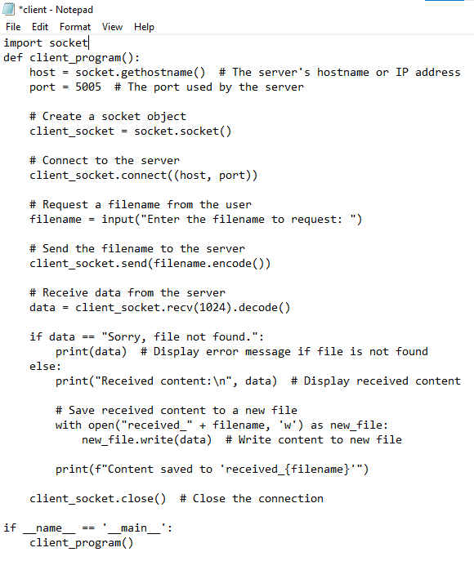

**OUTOUT: Server side**

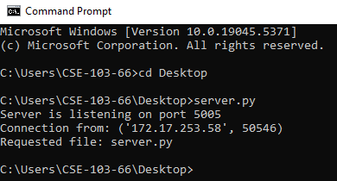

**OUTPUT: Client side**